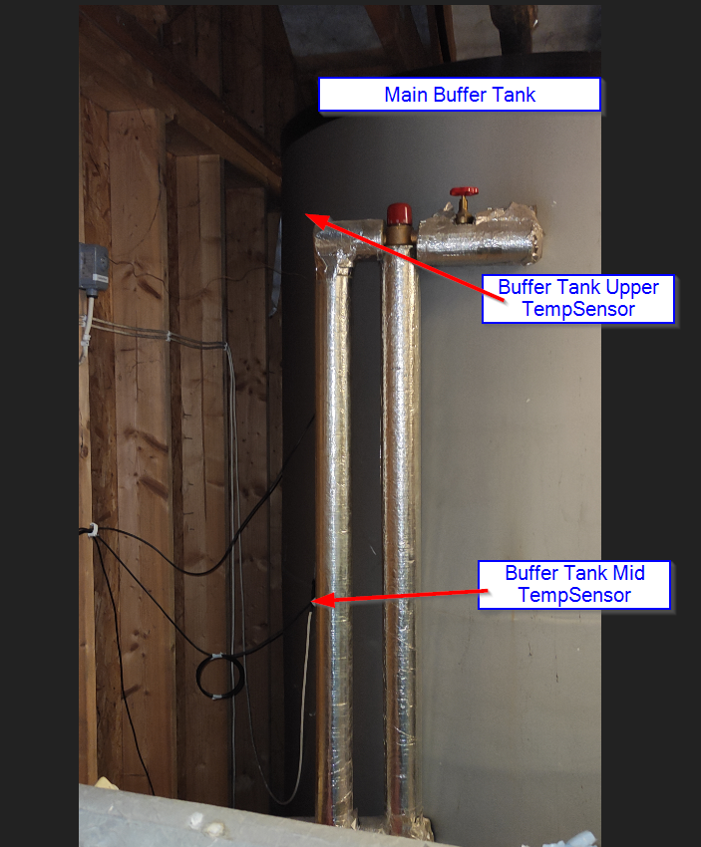

Figure 1 Main Gasification Buffer Tank with upper and mid temp sensors shown

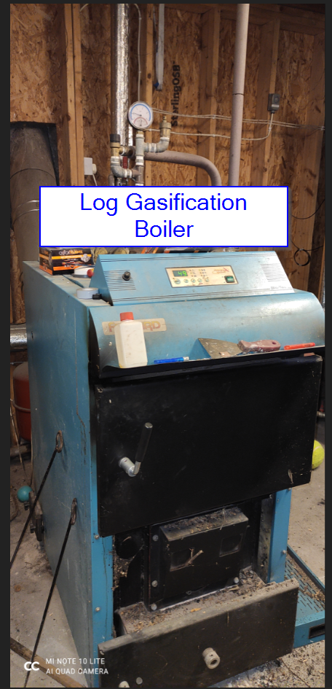

Figure 2 Main Log Gasification Boiler

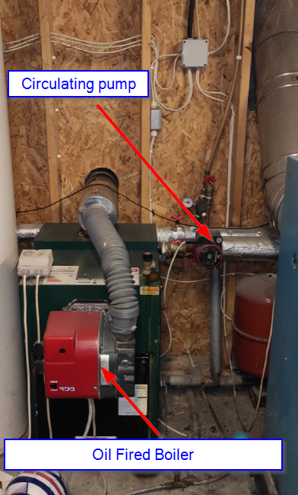

Figure 3 Oil fired boiler

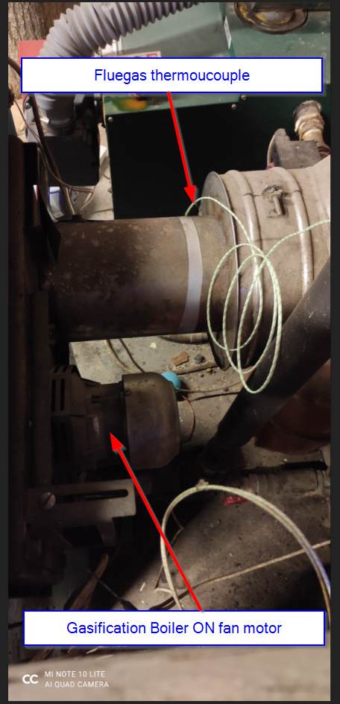

Figure 4 Rear of Gasification boiler

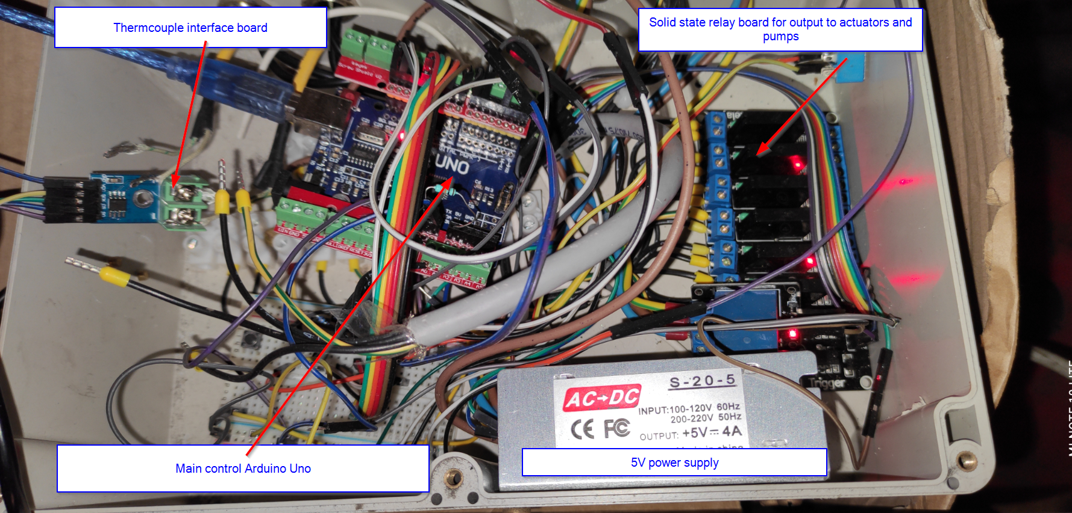Figure 5 Main control box (Admittedly not my finest hour, a bit of a mess. Underestimated size requirment)



Figure 6 Short video showing scrolling through LCD display